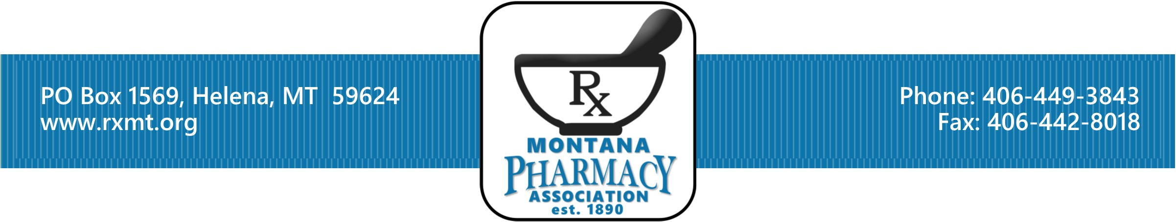

Board Nomination Form - 2023

The Montana Pharmacy Association invites you to nominate willing individuals who are members in good standing to seek election to the Board of Directors. You may nominate yourself. In 2023 we will be electing two pharmacists and one pharmacy technician. Nominations must be received in the MPA office by Friday, March 31, 2023.

Once the nominations are received, the nominees will be asked for a biographical summary to be included with the mail ballots sent to all eligible voting members. Voting ballots must be returned to the MPA office by Wednesday, April 26, 2023.

Election results will be announced, and the three new board members will be seated at the MPA Annual Business Meeting held in conjunction with the Northwest Pharmacy Convention,
June 1-4, 2023.

MPA By-Law Articles Guiding Election of Board Members

ARTICLE II Number and Qualifications

- There shall be 8 voting pharmacist members of the Board of Directors appointed by election who shall be active pharmacist members as defined in Chapter 1, Article 1, section 1 (a). There shall be no fewer than 3 practicing primarily in health-systems sites and no fewer than 3 practicing as community pharmacists.
  - Health-system pharmacy practice sites include, but are not limited to, hospitals, ambulatory care clinics, long-term care facilities and academia.
  - Community pharmacies, including compounding pharmacies and managed care are not considered health-system pharmacy sites.

b) There shall be 1 voting member of the Board of Directors appointed by election who shall be a pharmacy technician member as defined in Chapter 1, Article 1, section 1 (f).

c) There shall be 1 non-elected non-voting member of the Board of Directors who shall be the Dean of the University of Montana School of Pharmacy or his or her faculty designee.

d) There shall be 1 voting and 1 non-voting member of the Board of Directors who shall be a pharmacy student member as defined in Chapter 1, Article 1, section 1 (e). This individual shall be elected by the pharmacy students of the University of Montana School of Pharmacy.

ARTICLE III Election and Terms of Office

Section 1

Method of Election

- The nominated pharmacist and technician members of the Board of Directors as defined in Article II of this Chapter shall first be reviewed for by-law compliance to appear on the ballot by the board and if qualified, then elected by popular vote of all the members of the Association. This election shall be administrated via a mailed secret ballot as defined by the Board of Directors. The terms shall be staggered so as that only 2 of the elected pharmacists voting members of the Board as defined in Chapter 2, Article II, (a) are replaced each year.

- Balance among the pharmacist voting members of the Board of Directors will be maintained as outlined in Chapter 2, Article II, a). In the event a Board position from a specific practice site (i.e., health-system or non-health-system) is needed, the Board of Directors will conduct the election in a way to ensure the balance is maintained.

Terms of Office
The two pharmacist members shall serve four-year terms and may be re-elected for one additional consecutive term. The pharmacy technician shall serve a two-year term and may be re-elected for one additional term.

Name of person completing form Email Phone

Name of Nominee:
Place of Employment

Indicate Category: ___Community Pharmacist ___Health System Pharmacist ___Other, please explain, or ___Pharmacy Technician

Address:
PO Box or Street Address City Zip

Email Phone

You may also submit nominations online – www.rxmt.org ⇨ About Us⇨ Board of Directors.

Return this nomination form by Friday, March 31, 2023, to:
Montana Pharmacy Association
PO Box 1569, Helena, MT 59624
Phone: (406) 449-3843

